CMLE Director’s Report

March 1, 2021

It has been a busy month for us, as we scramble to keep our Extended Mini Grant program running and to collect information for our strategic planning process. Additionally, we are publishing two podcasts a week, and five or six articles per week on our website. All of that also goes out in our weekly newsletter. And we are responding to a few member questions and requests each week. It has all been good, and it’s good to have all these resources to share; and as with anything else - even a lot of a good thing is still a lot. But we are balancing and getting things done!

I was on a panel for the Metronet multitype library system last week, talking about being a System Director. Every other week Metronet has hosted panelists to talk about working in different kinds of library environments, and they have been very interesting and pretty popular. It is always interesting to hear what different library people are doing, in different types of organizations. It is pretty easy to fall into the routine of our own members, and it’s good to get other, newer, perspectives on how other places work.

I have also been submitting some conference proposals and book chapter proposals, to share the work we are doing at CMLE and beyond. I have been a librarian for a long time (over 20 years!), and often advocate for the importance of sharing information about work. Angie and I have been to several conferences to share CMLE’s success stories, but with the pandemic that was derailed. So, I’m working on that again to continue our participation in the larger world of the profession. One very nice result of the pandemic is that we can participate in conferences all over the place, and not incur any travel expenses and time! Although, I wish we were not having a global pandemic, I do hope that the flexibility of sharing things online we have all developed will continue. I think it makes us stronger if we can share more freely and easily.

I am on a committee for Minitex, working on building up the resources and training about Information Literacy for people across the state. There is widespread agreement that there is not enough information about how to use and understand information, as well as active disinformation and lies floating through social media and in other insidious places; and that libraries have a role to play in helping to make that better. I have been talking with them about potentially setting up a future season of Linking Our Libraries to focus on Info Lit skills - something we have been discussing anyway. We could build up CMLE’s offerings, and make a contribution to a larger program for our members and across Minnesota at the same time.

One step we are taking now to help build up a body of information about Info Lit is by posting some digital citizenship/information literacy training programs on our website each week, and distributing them in our weekly newsletter. And I am writing up a series of articles on using Info Literacy skills to examine news stories, and to bust some of the more far-fetch conspiracies being foisted on people online. Alone, these tools are not enough; but with a lot of other organizations working together to share good information, we can be part of making a difference for our members and for library people who are working to help their communities to identify good information and to beat down bad stories.

Additionally, we have been posting articles on book collections. The thinking was that we could collect books, or at least book topics, to make find and sharing resources easier for members. This week I finished up a series of articles about taking a virtual road trip on Route 66 - reading books set in each state along the highway each week. We started in Illinois, and just wrapped up in California. We have done other book themed series, and they just never catch on as much as I think they will. So, we will probably take a break from book recommendations for a while, and focus on information sharing or other skills, and see how that goes.

Here are the most-clicked-on articles and webpages for the last 30 days:

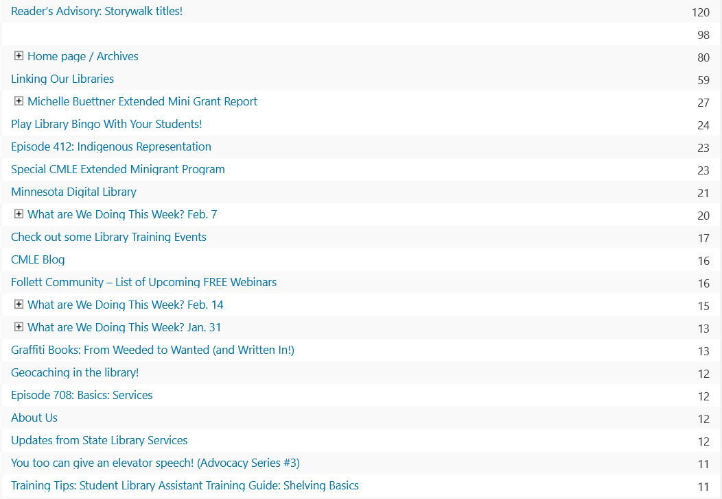

Here is look at our website daily stats:

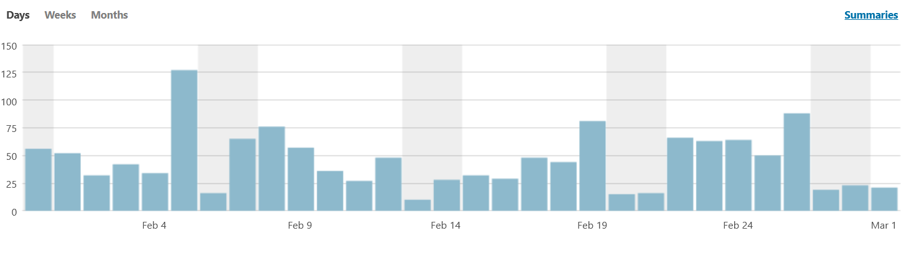

As I mentioned last month, our numbers are down from our 2020 numbers. I am not worried about this - I think most of our readers are in schools, and our school members are so stressed out that they do not have time to take on additional things. But, it does seem like a good time to change up some of our materials, and we will see how this goes for the rest of this school year.

These are our weekly website stats:

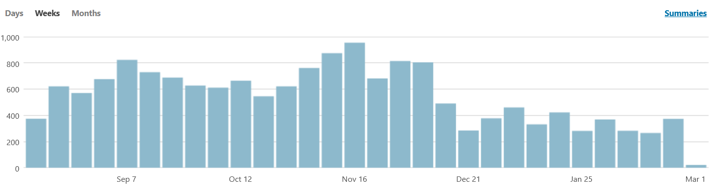

We did move up again last week, but I just think there is not a lot we are going to do with this right now. Our podcast numbers are up, and I think people would rather hear us cheerfully talking about library topics instead of having to read more articles. I am not going to worry about this right now (or ever, really); but as I said, we are making some changes to help ensure we are providing the material our members need.

And these are our monthly stats:

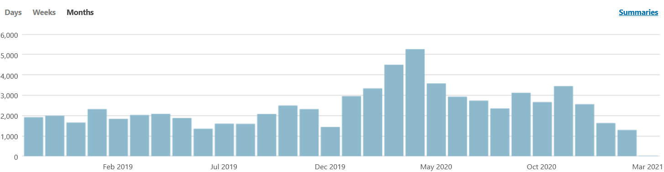

Same comments as above! Not worried, but making some changes.

Here are our stats for our podcasts. As I said last month, our podcasts have been pretty strong lately. We put in a lot of time and effort to make them good, so this makes me happy.

Here are the numbers for our Linking Our Libraries podcast (the training skills). We began Season Eight on this one last Thursday, with a new episode dropping every Thursday. Episode 810 is our 100th episode! While we have done many more than 100 episodes overall, there are 100 in this series. (Really, there are a few more because we’ve done a few bonus episodes; but this worked out just right, so I’m counting it as 100!)

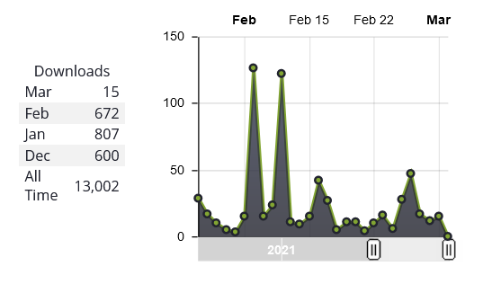

Here are the upcoming episodes:

|  |
| --- |
| 801: [Library Gardens](https://cmle.org/episode-801-library-gardens/) |
| 802: Hosting Virtual events |
| 803: Maker Spaces |
| 804: Cultural Competencies |
| 805: Podcasting |
| 806: Reference Interview |
| 807: Teen Service Competencies |
| 808: Library Boards |
| 809: Strategic Planning/Needs Assessment |
| 810: Episode 100!!! |

Our Reading With Libraries book group podcast are on hiatus right now (we only post one main podcast at a time), and we are putting up the short weekly book recommendation podcast on Tuesdays. This will be our final season of looking at Minnesota state parks, taking an interesting fact about each one, and recommending six books on that theme. We covered all over them, but two - just to make the numbers work out. After this, I have a chart of all the counties in Minnesota, an interesting fact about each, and we will record the same format: six books on the theme of that interesting fact.

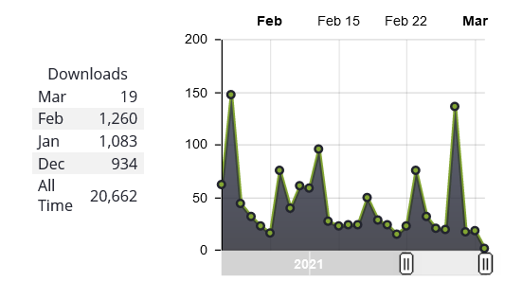

As you can see, our numbers here continue to go up! February was a new monthly record for us, which was great. It looks like they were climbing anyway; but we also posted four bonus episodes. In each we looked at a popular movie or TV show, chatted about it, and recommended books on the same topics. I think we really nailed some of the things being popularly discussed: Bridgerton, Soul, The Mandalorian, and Nomadland. So that probably helped to drive the numbers somewhat. We will likely be doing that again when this season of Linking Our Libraries is over, starting in May and running through the end of the school year.

These are the episodes from Season Six of Browsing Books. When these are done, at the end of April, we will call the new podcast (on counties) a new name, and post it to each of our current feeds as necessary to fill in content.

|  |
| --- |
| [Crow Wing State Park](https://cmle.org/browsing-books-crow-wing-state-park/) |
| [Temperance River State Park](https://cmle.org/browsing-books-temperance-river-state-park/) |
| Mille Lacs State Park |
| LaSalle Lake State Rec Area |
| Hill Annex Mine State Park |
| Tettegouche State Park |
| Wild River State Park |
| Lac Qui Parle State Park |
| Sakatah Lake State Park |
| MN Valley State Recreation Area |